These special discussions can be arranged in homes, restaurants, work places, etc., for individuals, families, or groups of friends. Just call the number below and ask the friend who gave this flyer to you for more information.

You may also call Don if you are interested in bring him to your area and hosting a meeting yourself. The number is (502) 897-4697.

MEET FOR QUESTIONS AT:

_______________________________________

_______________________________________

_______________________________________

_______________________________________

_______________________________________

TIME:_________________________________

DATE:________________________________

PHONE:_______________________________

E-MAIL:_______________________________

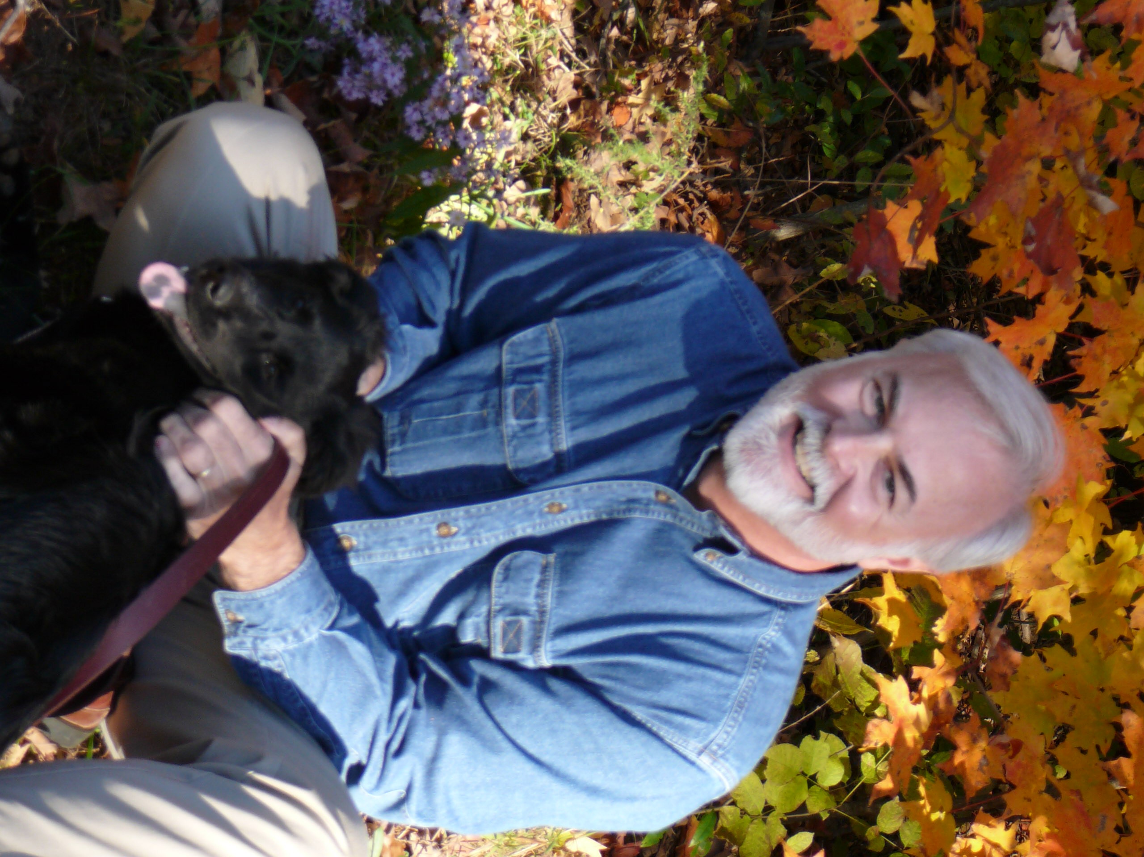

Dr. Don Whitney is a minister, professor, and author. With twenty-four years of pastoral experience, Don is professor of biblical spirituality and Senior Associate Dean at The Southern Baptist Theological Seminary in Louisville. He is the author of Spiritual Disciplines for the Christian Life (NavPress, 1991), How Can I Be Sure I’m A Christian? (NavPress, 1994), Spiritual Disciplines Within the Church (Moody, 1996), Ten Questions to Diagnose Your Spiritual Health (NavPress, 2001), Simplify Your Spiritual Life (NavPress, 2004), and Family Worship (Center for Biblical Spirituality, 2006). Don is founder and president of The Center for Biblical Spirituality, found at www.BiblicalSpirituality.org.

Don has conducted these home and small-group meetings both in the U.S. and overseas. He also speaks at conferences, retreats, colleges, and seminaries. His beliefs are those held by Christians for centuries and are presented in a clear, understandable manner. Don is married to Caffy and they have a daughter, Laurelen. The Whitney family lives near Shepherdsville, KY.

Don Whitney
2825 Lexington Road
Louisville, KY 40280 (502) 897-4697 Info@BiblicalSpirituality.org


everyone has

about

God
Jesus Christ
Christianity
The Bible

Here’s an opportunity

For Some
Everyone has important questions.

Questions like . . .

Who is God? How can I know Him?

Is Jesus Christ God?

Does God care about me?

Is the Bible true and reliable?

What does God expect of me?

How can I find purpose for my life?

I feel so guilty; can I be forgiven?

How can I find lasting peace?

What does the Bible say about the future?

Where can I find hope?

Why is there sickness and suffering?

What about all these different religions?

How can I know I’ll go to Heaven?

Does the Bible have answers for family problems?

What are your questions?

Just about everyone has many questions they have always wanted to ask about God, Jesus Christ, Christianity, and the Bible. Great questions like these are crucial to working through your life’s most significant issues and deepest struggles.
However, many of us simply have never had the opportunity to ask an experienced Bible teacher about these questions. And some who attend church have been too embarrassed to ask these questions there or were unsure if such queries would be welcome.

Soon you’ll be provided with a non-threatening, informal atmosphere to ask the questions that have concerned you. And you know you’ll get a thoughtful reply from someone who will genuinely listen.

An opportunity for answers

You are invited to a small-group meeting where you can ask your questions about matters like these, and ask them in a friendly, comfortable setting.

Our special guest in this question-and-answer meeting is Dr. Don Whitney. Don is a minister who has been attempting to meet honest questions with honest answers in home and small-group gatherings in the U.S. and overseas since 1977.

When you attend a small-group meeting with Don in a home, office, restaurant, etc., you will find it a relaxed and beneficial time.

There’s . . .

- no pressure,
- no put-downs,
- straight answers,
- no embarrassment,
- no question too small,
- the freedom to just sit and listen.
What will the meeting be like?

In order to provide a platform for questions and discussions, Don will spend the first few minutes giving an overview of the Bible and explaining its main message. After that, the floor is open for any and all questions relating to God, Jesus Christ, Christianity, and the Bible. Don will also be available for those who want to talk with him privately after the meeting.

Incidentally, no one will ask you for money. No one will try to sell anything to you. You will not be asked to sign anything. No one will phone you or visit you afterwards (unless you request it).

Then why is Don coming and why was I invited? Both Don and the one hosting the meeting know that most people have lots of questions about spiritual issues but often have limited opportunities for satisfying answers. Jesus Christ loved to meet with people and to answer their questions. Don and your host believe that this kind of hospitality and dialogue is something Jesus would do and something He would have them do in His name.

Childcare and refreshments are provided in most of the meetings held in homes. Please ask if you are unsure. We don’t want childcare difficulties to keep anyone from attending.

Give it a try!

Many people have found some real answers in meetings like these. Instead of hearing answers to questions no one is asking, they’ve come away with answers to questions they’ve been asking for years. Maybe you can find some long-sought answers too. You’ll never know unless you attend. Please do!

